Manual Testing class 01 Date:01-12-2023

3 types of application we test;

1. Web applications ------ the application which required internet to use them on pc they are called web applications, any application that require internet access to run. Example, amazon, websites, Facebook, WhatsApp, Instagram.
2. Desktop application ---- application that do not need internet to run on computer and which work only in computer. And does not require to use web browser. Photoshop, word, excel, power point, illustrator. IntelliJ j, eclipse.
3. Mobile application ------------ the application which are used in mobile phones, whether they required internet or not. Facebook, WhatsApp, Instagram, calculator, calendar

What is manual testing ???

The process of finding defects, bugs, error in a software or program by manually executing the program test cases.

* a process in which testers play role as end users to compare the behavior of a developed piece of code (software, module, feature, etc.) against expected behavior (Requirement)
* prerior testing that must be carried out prior to start automating the test cases. If manual test case fail we cannot automate until it pass, so **Manual Testing is important.**

**What is automation testing?**

**Automation helps us to do, what we are doing better, for us to be efficient.**

**Automation mean increase the efficiency . (increase performance)**

The main goal of automation testing is to increase the test efficiency and develop software value.

Automation testing uses automation tools to write and execute test cases, no manual involvement is required while executing an automated test suite.

**How do we start testing ???**

Example you have to test manually amazon prime video.

1. Business requirement;

User should be able to navigate amazon prime video.

1. User story 1233(artifact) User story is a document, artifact is also a document

Acceptance criteria ;

As an amazon user I should be able to navigate prime videos.

Why we test??

What is quality??

What is goal of testing why it is important.

What is software testing?? The process to run a program automated to find defects

What is manual testing?? The process to run a program manually to find defects

Why do the tester test ??? tester test is that developed story is same as the clients requirement.

What is production mean ??

**STLC (software testing cycle)**

1. Requirement analysis

Suppose two-week sprints start from Monday and developers will start to coding and in free time what will do the tester ??? they will analysis the requirement. What does this mean?

1. Tester team will read the user story
2. Understand the user story
3. Plan to test the user story.

**SMART criteria follow**

1. Specific --- you need what to do specific
2. Measurable -------- ho long it will go to test a case or requirement
3. Attainable -------------- can we finish this goal on time
4. Relevant -------------- is this requirement relevant to same page, or it is from last sprint.
5. Time based ------------ would you have enough time to complete testing in given sprint if not then don’t wait tell his team as soon as you realize.

What is step details/description --- this is action performed by user

What is expected result? ----- this is not an action, this is that what happens when an action is performed

Expected result is what the user take action after what to suppose to be happen.

----------------------------------------------------------------------------------------------------------------------------------------------------------------------------------------------------------------------------------------------------------------------------------------------------------------------------------------------------------------------------------------------

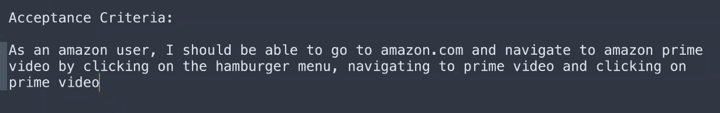

STLC with real example understanding.

Certainly, let's go through each step of the Software Testing Life Cycle (STLC) using a real example of testing a calculator application:

1. **Requirement Analysis**:
   * **What to do**: Identify the functionalities and requirements of the calculator application, such as addition, subtraction, multiplication, and division.
   * **Example**: For the calculator application, you might determine that it needs to support basic arithmetic operations, handle both positive and negative numbers, and display results accurately.
2. **Test Planning**:
   * **What to do**: Create a test plan outlining the testing approach, objectives, scope, resources, and timelines.
   * **Example**: In the test plan for the calculator application, you might decide to test each arithmetic operation separately, define test cases for different scenarios (e.g., testing with whole numbers, fractions, and decimals), and specify the testing tools and platforms to be used.
3. **Test Design**:
   * **What to do**: Design test cases to cover various scenarios for each functionality of the calculator application.
   * **Example**: For addition, a test case might involve entering two positive integers, pressing the addition button, and verifying that the correct sum is displayed. Similarly, for subtraction, a test case might involve entering a larger number followed by a smaller number and ensuring the correct difference is displayed.
4. **Test Environment Setup**:
   * **What to do**: Set up the testing environment with the necessary infrastructure to run tests, including the calculator application installed on different devices or simulators.
   * **Example**: You might set up the testing environment by installing the calculator application on various devices (e.g., smartphones, tablets, computers) or using simulators to emulate different operating systems and screen sizes.
5. **Test Execution**:
   * **What to do**: Execute the test cases in the prepared test environment and verify the results.
   * **Example**: Testers will perform the specified actions on the calculator application, such as entering numbers and selecting arithmetic operations, and verify that the expected results are displayed correctly.
6. **Defect Tracking and Management**:
   * **What to do**: Log any defects discovered during testing into a defect tracking system and prioritize them for resolution.
   * **Example**: If testers find issues like incorrect calculation results or user interface glitches, they would log these defects into a tracking system like JIRA or Bugzilla. The severity and priority of each defect would be determined based on its impact on the application's functionality.
7. **Test Reporting**:
   * **What to do**: Generate test reports summarizing the testing activities, including test execution results, defect metrics, and test coverage.
   * 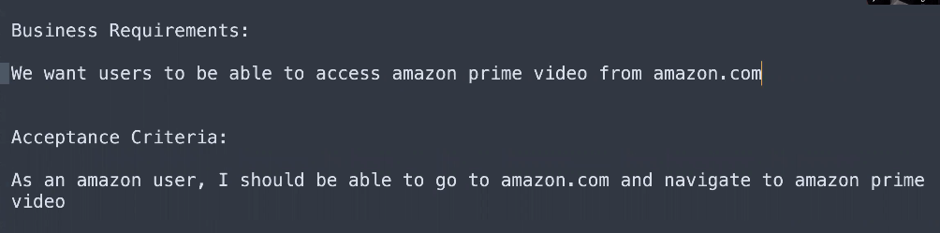**Example**: Test reports might include metrics like the number of test cases executed, pass/fail status, defect trends over time, and test coverage achieved. These reports provide stakeholders with insights into the quality of the calculator application and help make decisions about its release.
8. **Test Closure**:
   * **What to do**: Evaluate the testing process, document lessons learned, and prepare a test closure report.
   * **Example**: After testing is complete and all defects have been addressed, the testing team would assess the overall testing effort, identify any areas for improvement, and document lessons learned. The test closure report would summarize these findings and provide recommendations for future testing activities or releases.

Manual Testing class 02 Date; 02-12-2023

**STLC software testing life cycle**

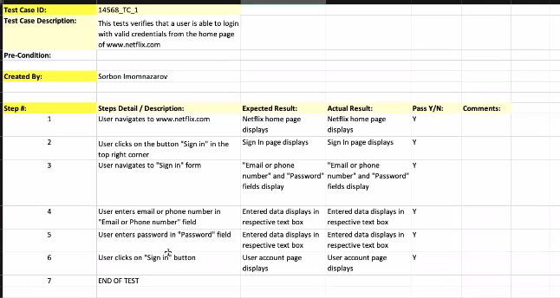

2. test planning

-------------------------------------------------------------------------------------------------------------------------------------------

Let’s take example when you go to amazon the page which you see is live page of amazon.

At this page, developers do not develop code, tester do not test on this live page, then where they do all of these things.

They do all of development in an environment. What is environment lets understand. What is last cycle step of SDLC. Live production or maintenance.

**What is environment**

Environment is you can say that this is production copy of production or developed code.

1. **Development Environment Dev**- where developers make code, after completion of code they forward their code to test environment. It means they send the copy of their cod to tester for testing.
2. **TEST** **Environment QA** Quality assurance – the copy of code send by tester is tested thoroughly, after completing testing the tester send this copy to stage environment.
3. **Stage environment user acceptance testing UAT;** at stage environment there is client present mean there is owner who is developing this software from software house. The owner test hi application itself if he finds the bug during testing it will be very bad for tester because they first test this code thoroughly and pass it.
4. **Production** Environment – this copy from stage environment goes to production environment, live application that is available for all real users/end user/customers where we usually don’t have access as testers or only have read-only access.

-----------------------------------------------------------------------------------------------------------------------------------------

BDD we use behavioral driven development for business rules/ business requirements

Key words

In manual testing , the test case is called classic manual test case.

This is cucumber test case ;

Scenario ---------- acceptance criteria --- user story.

Given --- this is pre condition

When ---- this is action

And ---- this is more addition of more addition of details about a test case step

Then --- this is the result

Scenario ; as admin login to hrm login page

Given --- user navigate to hrm website

And --- user see login panel

And -- enter valid password and username in text box

Then ---- user see display of dashboard.

-------------------------------------------------------------------------------------------------------------------------------------------------

Class 03 manual testing Date; 03-12-2023

Cucumber Scenario

Writing cucumber scenario manually is very important because it will use in your automation testing. If manual written testing is poor your automation testing will also poor.

We use BDD to describe the business rules/requirements/user stories/acceptance criteria

Rules to write cucumber scenario

1. First letter of keyword should be capitalized
2. Should word can be used in cucumber test case but use this inside then keyword.
3. When you use And keyword it means it is continual of previous step.
4. Ali is student. And he goes to school, And he live in Lahore, And he is good player in all of these sentences And keyword showing the continuity of previous keyword. If you use every time ali is student, ali is going to lahore, ali is blah, blah every time using ali word is not good with And keyword.
5. Use quotation mark to inter the name of “Username” and “password” name starts with capital word because name always start with capital word.
6. Keyboard button should be by default , it means you don’t need to write a case that press enter button to submit is should be by default in window.

Example cucumber scenario

1. Given a user is on syntax hrm home page.
2. And enters the username into the “Username” text box
3. And enters the password into the “Password” text box
4. And clicks on “Login” button.
5. Then user should be login.

Simplified the above scenario

1. Given a user is on syntax hrm home page.
2. When user enters the valid credentials
3. Then user should be logged in.

What is bug ??

What should do when bug is found ??

Reproduce the bug again, repeat the process again, do the same steps again and again, at least 5 times. If at 4th repetition bugs is not present and at 5th repetition bugs is present what this kind of bugs is called. **They are called intermittent bugs.**

Why intermittent bugs happens ?? it is because of coding, report to development team they will fix it. And some times they could not understand what is this happened.

Before reporting a bug you must clear the following points

What is bug life cycle

1. Step one -------- reproduce the bug at least 5 times
2. Step two ---------- read the requirements clearly
3. Step three ------- documents all the steps how and where you find the bug.

The following documentation is for step 3 only.

This is the example how to write the document

How you will report and document it to development team??

Step 1. In safari web browser search engine “world Disney ”

Step2 . click on the first link

Step 3. Select the date from 28 November to 30 November

Step 4. Find 5 adult and 2 kids, 12 year and 17 years old

Step 5. Click find results

Step 6. Selected price range to be over 250$.

Step 7. I clicked on final result

Step 8. Expected result many option should be display

Step 9. Actual result only 2 option display .

Browser used; google chrome

Time ; 8:00 to 8:30 standard time;

Operating System; window

Date; 12-12-2023

1. Hey dev team please fix the bug
2. If the bug is fixed retest the bug
3. If your test is passed you close the bug.

What is severity and priority

* Severity is defined as the level of impact that bug has on the functionality of application/system.
* Severity indicates the seriousness of the defect on the product functionality
* Priority is defined as the order in which a defect should be fixed. Higher the priority the sooner the defect should be resolved.
* Priority indicates how soon the bug should be fixed

Priority types

1. Show stopper --- amazon.com not found. , OTP not working, enter in bank with wrong credentials
2. Major -- enter your username but not password it logins
3. Minor. --- on amazon page new year offer pic not visible but name is showing
4. Cosmetic --- the name of any option is mis spelled but it is working.

Severity types.

Low level

Medium level

High level

There are two types of testing

1. Functional testing
2. Nonfunctional testing
3. **What is Functional testing???**

Is a type of testing when we test the functionality of the application. Button testing, text box testing, drop downs testing, radio button testing, check box testing. Functional testing is done by tester.

1. **What is Nonfunctional testing??**

The testing which is done by developer to check the non-functional requirements of application. for example, performance of application. for example, on amazon black Friday sale the website was down the server was down because there were too much users and the performance of website was very low, due to which they lose lot of money.

Performance testing mean how many user can use that application at once. Security testing.

**Types of Non-Functional Testing**

1. [Performance Testing](https://www.scaler.com/topics/performance-testing-in-software-testing/)
2. Load Testing
3. Stress Testing
4. Volume Testing

Functional non-functional

|  |  |  |
| --- | --- | --- |
| Types | 1.Unit Testing 2.Integration Testing 3.System Testing 4.Regression Testing 5.Database Testing | 1. Performance Testing 2. Load Testing 3. Stress Testing 4. Volume Testing 5. Scalability Testing |

**What is Software testing Hierarchy??? And testing Environment are same things. these are functional testing**

1. **Unit testing**;

in this phase developers do the testing of their code. Code testing. They test is there code is

1. **Integration testing/test environment**.

in this phase tester do testing to check the functionality, here integration testing means let’s take an example of amazon. Amazon has lot of pages, every page is integrated with main page of amazon, integration mean you have to test all the separate pages linked with amazon.

1. **System testing/stage environment/.**

In this testing phase clients do test of his application. he tests all the system testing like, security testing, performance testing and functionality testing that s why this is called system testing. , performance testing, security testing, front end , back end, server testing.

1. **Acceptance testing/UAT testing;**

This testing is performed by customer, users who will use this app. Mostly the has a team that called UAT team they test it completely.

Important question what is difference in testing hierarchy and testing environment??

Testing hierarchy mean testing of application at different levels before sending it to customer. And testing environment mean testing of software at different stages before making it live before sending it to on internet.

**Acceptance criteria are the conditions a software product must meet to make it acceptable to end customer. On the other hand, acceptance testing checks whether a software product meets the acceptance criteria.**

**What is white box testing ?? this is non-functional testing answer is that this is called unit testing, this is called dev environment???**

This is testing where internal part of testing is performed, mean you need to understand the code. You need to know how the code works in an application. Only developers perform white box testing and unit testing.

**What is Black box testing???this is functional testing. Answer is that this is called integration testing this is called test environment**

The testing in which internal part of coding is not tested, not known just functionality is tested.

Black box testing is a testing approach where the tester does not have any knowledge of the internal workings, code structure, or implementation details of the software being tested. The tester treats the software as a "black box" and focuses on its inputs, outputs, and the system's behavior.

**There are more types of testing;**

1. **smoke testing** -------- **functional testing** --Red Flag if it fails. smoke test is conducted every day. the basic most important testing of main functions quickly is called smoke testing, for example login page testing . lets take example of car, before run to car checking the brakes, lights of car , tiers of car are most important and basic thing to check quickly. Radio button, ac, Bluetooth are not important to check.
2. **regression testing** ----wapsi----functional testing -- checking the functionality of existing features after the update or fix bug. regression testing mean after any update or fixing bug or any change in application is then still the application’s other functions are working which were already correct.

Imagine you have a favorite video game. Every time the game developer adds something new, like a cool feature or fixes a bug, they want to make sure they didn't accidentally break any other parts of the game. So, they play through the game from the beginning to see if everything still works as expected, even the old stuff. the functionality testing which is not important in smoke testing left behind other testing is called regression testing. Examples like spell testing , image missing testing on page, if we take example of car Radio button, ac, Bluetooth are not important to check.

1. **performance testing/stress testing/load testing/volume testing; this is non functional testing** these testing are same as in system testing clients perform performance testing. Can 2000 user login to the application at the same time. How much level of load , or user it can bear at a time.
2. **What is 508 compliance testing??**

-- Section 508 is a requirement for all websites, and in general, for all federal departments and agencies to ensure that their electronic information & technology (EIT) is accessible to people with disabilities.

--508 Compliance testing is to make sure disable people can use the application as well.

--Mandatory for government websites.

--Popular tool used for 508 testing is JAWS(Job Access With Speech)

1. **Ad hoc/exploratory/random testing --- this is Latin word which mean “for this situation”; exploratory mean discover, search bugs. --- functional testing**

Before launching the application , random testing is done bye every one to find bug.

--- Testing performed without planning and documentation.

---- Informal testing OR least formal test method.

---- A lot of Bugs can be find in ad-hoc testing.

---- Performed mostly after official testing is done and still sometime is left for testing the application.

----- It can be also called Exploratory testing, Random Testing

give yourself around of applause اپنے آپ کو تالیاں بجائیں۔

more types of testing;

1. White box testing --- knowing the internal parts of testing ---- non functional testing --- interview question
2. Black box testing ------ without knowing the internal part of testing ------ functional testing
3. Positive testing --- enter valid credential to login in any website --- functional testing
4. Negative testing -----valid invalid credential to login any website if it did not login it mean test is passed --- functional testing
5. Boundary value analysis --- if in any text box on webpage required 10 characters then put 11 characters to check this is correct or not. ------ functional testing

API testing is a type of software testing that analyzes an application program interface (API) to verify that it fulfills its expected functionality, security, performance and reliability.

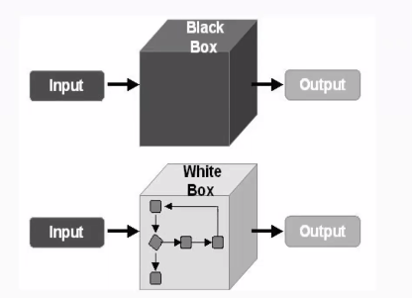

Class 04 manual Testing Date;04-12-2023

Jira

Your sitte:babar1234

Email; [babaraliengineer32@gmail.com](mailto:babaraliengineer32@gmail.com)

Jira

<https://babar1234.atlassian.net/jira/software/projects/SCRUM/boards/1/backlog>

naïve ======== sada, bhola bhala , Saada loho

you just my naïve --------- ye sun kr Khushi hoi.

<http://jira.syntaxtechs.net/secure/Dashboard.jspa>

BABAR JIRA software

<https://www.atlassian.com/ondemand/signup/confirmation?ondemandurl=babar123456&cloudId=a9249a92-c2d0-4d46-bc4f-7fdafaac9d3e&requestId=195024969&products=jira-software.ondemand>

<https://babar123456.atlassian.net/jira/software/projects/SCRUM/boards/1/backlog> jira my account

jira project management tool

what are tickets -------- issue

everything in jira is an issue, task is issue, test case is issue, user story is issue everything in Jira is called issue but in other project management tool they call tickets, they may call issue.

How do test in JIRA software ???

1. First you create backlog
2. Then create sprint backlog
3. Then create option click and write cucumber test case and do testing of assigned sprint ticket or backlog.

Epic ----ایک غیر معمولی لمبا اور مشکل کام یا سرگرمی---۔ -------- bahdarana ------ '**narrated in a grand style------ shaaandaar ----------taweel nazam**

**Are you ready? or are we ready.**

**Are you done? Or are we done.**

When we are linking a ticket with another ticket then what are we doing?????

It means we are making a relation between them. Somehow the linked tickets have relation with each other.

When we link one ticket to another ticket it means one me make a link with user story and when you open that user story at the end you see all the links and name of person who did the work on that user story.